System Architecture

Overview
This system is a monolith three-tier distributed architecture: Presentation tier, frontend; Application tier, backend; and Data tier, Database.
Presentation tier, implemented using React, is the layer with which the clients interact. It houses the user-interface UI and communicates with the application tier through HTTPS and REST APIs.
The application tier is the heart of the system; it contains all the business logic and coordinates the present modules. It communicates with both the presentation and database layers.
The database tier contains all the data needed for the system. It communicates with the application tier through JDBC API.

High-Level Diagram
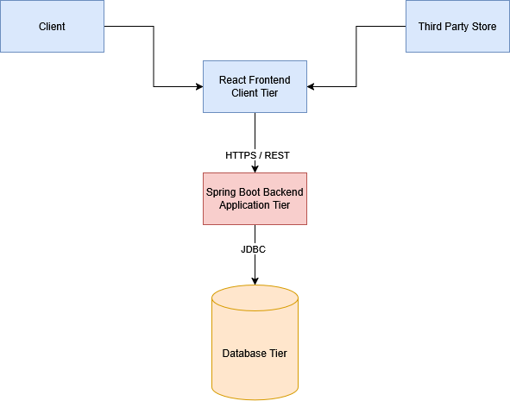

Detailed Backend Layout
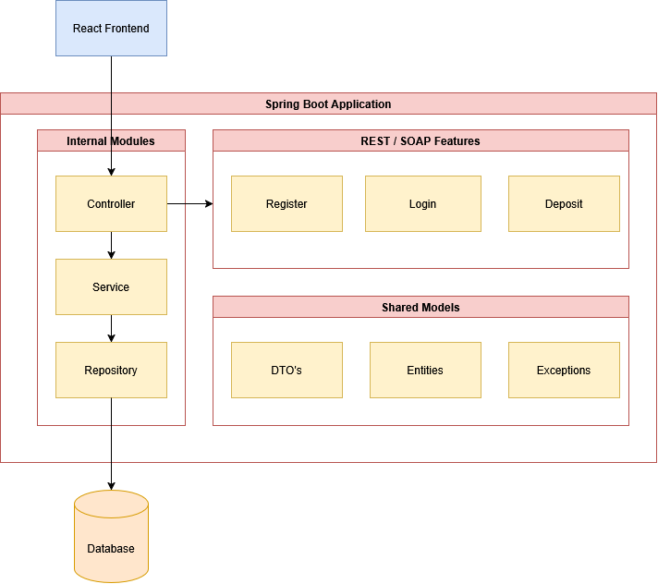

Internal Modules
The backend is implemented as a Spring Boot monolith and is internally structured into modules and layers to achieve separation of concerns. The internal architecture is patterned into controller, service, and repository.
The controller deals with HTTPS requests to communicate with the frontend layer and returns the HTTPS response. It passes its data to the service class.
The service contains all the business logic of the entity it deals with, e.g., users. It processes operations, validate conditions, and coordinates with repositories. It is the core of the system’s logic.
The repository manages data access and consistency. They provided an abstraction over the database tier and allows the service layer to manipulate the data entities without writing any low-level SQL queries.

Three Features using REST
Register was chosen because it is the entry point of the entire system, and every other feature depends on having an account. It demonstrates a complete web service cycle: receiving, validating, and processing input, then returning a structured response. It requires no prior state or authentication making it the simplest possible standalone service.
Login was chosen because it demonstrates token-based authentication which is a core distributed systems concept directly relevant to the system. It shows how stateless authentication works across a distributed system; the server issues a token and never needs to store session state, which is fundamental to scalability.
Deposit was chosen because it demonstrates a transactional web service which validates authorization via JWT, performs a state-changing operation on the database, records an audit trail in the transactions table, and returns a confirmation. This covers more web service concepts than a simple read operation would and directly shows distributed database consistency.

REST Implementation
The three features would be implemented using REST. Spring Boot provides native REST support via @RestController as REST is built on standard HTTP. Every endpoint written is automatically a REST web service requiring minimal configuration. Data is exchanged in JSON which is lightweight, human readable, and integrates directly with the React frontend without any transformation.
SOAP was considered but rejected because it requires Spring-WS as a separate dependency, a WSDL file describing every operation, XML schemas for every request and response, and a completely different controller model. Every request and response are wrapped in a heavy XML envelope, and the React frontend cannot consume SOAP directly without an additional translation layer. This adds complexity that is not justified given that SOAP’s strengths are not required.

Shared Models
These common models are centralized to be used by the whole system to avoid redundancy and improve consistency. They represent the core business objects stored in the database.
The design rule is that any model used by multiple modules is placed in the shared models, while models used by only one module remain local to that module.
Shared Entities:
- User
- Item
- Transaction
- Inventory
Shared DTO’s
- UserResponseDto
- ItemDto
- TransactionDto
DTO’s are used to transfer structured data between backend and frontend without directly exposing internal entity classes.
Exceptions
- InsufficientBalanceException
- ItemNotFoundException
- UserNotFoundException
- UnauthorizedActionException
These custom exceptions provide clear and reusable error handling across the system.

Benefits of this Architecture
Security: The React frontend has no direct database access — all data flows through the application tier’s-controlled REST interface, which acts as a mandatory gateway for authentication, authorization, and input validation.
Testability: each tier and each internal layer can be tested in isolation, allowing failures to be precisely located without ambiguity.
Modularity: Separating the frontend, backend, and data layers makes the system easier to organize and understand. Within the backend, the layered structure further improves modularity.
Maintainability: Controllers, services, and repositories each have a specific responsibility. This makes the code easier to maintain and extend as the system grows.
Reusability: The shared models package allows common entities, DTOs, and exceptions to be reused across multiple modules without duplication.
Scalability: CockroachDB supports horizontal scaling and distributed storage, which makes the data layer more scalable than a traditional single-node database.
Clarity: The architecture is straightforward: React handles presentation, Spring Boot handles application logic, and CockroachDB handles persistent distributed storage.
Transparency: The architecture hides internal implementation complexity from users and higher-level components. For example, the frontend interacts with a unified REST interface without needing to know the details of backend layering or distributed database replication.

